# Assignment 8.1

**Task 1:**

(Password Strength Validator – Apply AI in  
Security Context)  
• Task: Apply AI to generate at least 3 assert test cases for  
is_strong_password(password) and implement the validator  
function.  
• Requirements:  
o Password must have at least 8 characters.  
o Must include uppercase, lowercase, digit, and special  
character.  
o Must not contain spaces.  
Example Assert Test Cases:  
assert is_strong_password("Abcd@123") == True  
assert is_strong_password("abcd123") == False  
assert is_strong_password("ABCD@1234") == True

**Prompt:**

Generate at least 3 assert test cases for a function is_strong_password(password) that validates passwords. The rules are:

* Minimum 8 characters,
* Must include uppercase, lowercase, digit, and special character,
* Must not contain spaces.  
  Provide asserts where the expected output is True and others where it is False.

**Code generated:**

**Output**

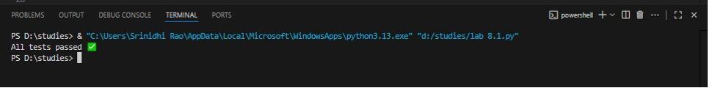

**Observation**

The code defines a function is_strong_password that checks if a password meets security rules. It verifies the length (minimum eight characters), absence of spaces, and presence of at least one uppercase letter, lowercase letter, digit, and special character. Using regular expressions, each condition is tested. Assert statements confirm correctness by checking valid and invalid passwords.

**Task 2:**

(Number Classification with Loops – Apply AI for  
Edge Case Handling)  
• Task: Use AI to generate at least 3 assert test cases for a  
classify_number(n) function. Implement using loops.  
• Requirements:  
o Classify numbers as Positive, Negative, or Zero.  
o Handle invalid inputs like strings and None.

o Include boundary conditions (-1, 0, 1).  
Example Assert Test Cases:  
assert classify_number(10) == "Positive"  
assert classify_number(-5) == "Negative"  
assert classify_number(0) == "Zero"  
Expected Output #2:  
• Classification logic passing all assert tests.

**Prompt:** *"Generate at least 3 assert test cases for a function classify_number(n) that classifies input as Positive, Negative, or Zero. The function should handle invalid inputs (like strings, None) and include boundary cases (-1, 0, 1). Provide asserts where the expected outputs match the classification."*

**Code generated:**

**Observation**

The classify_number function checks if input is a number and classifies it as Positive, Negative, or Zero using a simple loop. Invalid inputs like strings or None return "Invalid Input". Assert statements test normal, invalid, and boundary cases, ensuring the logic is correct.

**Task 3:**

(Anagram Checker – Apply AI for String Analysis)  
• Task: Use AI to generate at least 3 assert test cases for  
is_anagram(str1, str2) and implement the function.  
• Requirements:  
o Ignore case, spaces, and punctuation.  
o Handle edge cases (empty strings, identical words).  
Example Assert Test Cases:  
assert is_anagram("listen", "silent") == True  
assert is_anagram("hello", "world") == False  
assert is_anagram("Dormitory", "Dirty Room") == True

**Prompt:**

Generate at least 3 assert test cases for a function is_anagram(str1, str2) that checks if two strings are anagrams, ignoring case, spaces, and punctuation. Implement the function so it passes all tests, including edge cases like empty strings and identical words.

**Code generated:**

**Output:**

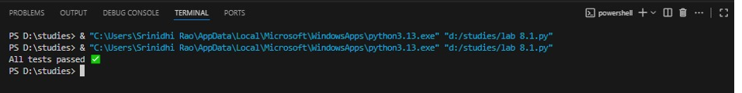

**Observation**

1.The is_anagram function cleans both input strings by removing spaces and punctuation, converting to lowercase, and sorting the characters.

2.It then compares the cleaned versions to determine if they are anagrams.

3.The assert test cases check for typical anagrams, non-anagrams, case insensitivity, spaces, punctuation, empty strings, and identical words.

4.The function passes all tests, correctly identifying anagrams under the specified requirements

**Task 4:**

(Inventory Class – Apply AI to Simulate Real-  
World Inventory System)  
• Task: Ask AI to generate at least 3 assert-based tests for an  
Inventory class with stock management.  
• Methods:  
o add_item(name, quantity)  
o remove_item(name, quantity)  
o get_stock(name)  
Example Assert Test Cases:  
inv = Inventory()  
inv.add_item("Pen", 10)  
assert inv.get_stock("Pen") == 10  
inv.remove_item("Pen", 5)  
assert inv.get_stock("Pen") == 5  
inv.add_item("Book", 3)  
assert inv.get_stock("Book") == 3  
Expected Output #4:  
• Fully functional class passing all assertions.

**Prompt:**Generate at least 3 assert-based test cases for an Inventory class with methods: add_item(name, quantity), remove_item(name, quantity), and get_stock(name). Implement the class so it passes all tests.

**Code generated:**

**Output:**

**Observation**

* The Inventory class manages stock using a dictionary.
* add_item increases the quantity for an item, creating it if needed.
* remove_item decreases the quantity but never below zero.
* get_stock returns the current quantity or zero if the item doesn't exist.
* The assert tests check adding, removing, and retrieving stock for different items, ensuring the class works as expected.

**Task 5:**

(Date Validation & Formatting – Apply AI for  
Data Validation)  
• Task: Use AI to generate at least 3 assert test cases for  
validate_and_format_date(date_str) to check and convert dates.  
• Requirements:  
o Validate "MM/DD/YYYY" format.  
o Handle invalid dates.  
o Convert valid dates to "YYYY-MM-DD".  
Example Assert Test Cases:  
assert validate_and_format_date("10/15/2023") == "2023-10-15"  
assert validate_and_format_date("02/30/2023") == "Invalid Date"  
assert validate_and_format_date("01/01/2024") == "2024-01-01"

**Prompt:**  
Generate at least 3 assert-based test cases for an [Inventory](vscode-file://vscode-app/c:/Users/Srinidhi%20Rao/AppData/Local/Programs/Microsoft%20VS%20Code/resources/app/out/vs/code/electron-browser/workbench/workbench.html) class with methods: [add_item(name, quantity)](vscode-file://vscode-app/c:/Users/Srinidhi%20Rao/AppData/Local/Programs/Microsoft%20VS%20Code/resources/app/out/vs/code/electron-browser/workbench/workbench.html" \o "), [remove_item(name, quantity)](vscode-file://vscode-app/c:/Users/Srinidhi%20Rao/AppData/Local/Programs/Microsoft%20VS%20Code/resources/app/out/vs/code/electron-browser/workbench/workbench.html" \o "), and [get_stock(name)](vscode-file://vscode-app/c:/Users/Srinidhi%20Rao/AppData/Local/Programs/Microsoft%20VS%20Code/resources/app/out/vs/code/electron-browser/workbench/workbench.html" \o "). The class should handle negative quantities and removing more items than are in stock by raising a [ValueError](vscode-file://vscode-app/c:/Users/Srinidhi%20Rao/AppData/Local/Programs/Microsoft%20VS%20Code/resources/app/out/vs/code/electron-browser/workbench/workbench.html" \o "). Implement the class so it passes all tests, including edge cases like removing all items or checking stock for a non-existent item.

**Code generated:**

**Output:**

**Observation:**

1. The program defines a function validate_and_format_date(date_str) to check whether a given string is a **valid date** in MM/DD/YYYY format.
2. If the string is a valid date, it converts and returns the date in the **YYYY-MM-DD format**.
3. If the string is invalid (wrong format, invalid month/day, or non-date input), the function returns **"Invalid Date"**.
4. Several **assert test cases** are written to automatically verify the correctness of the function for:
   * Valid date inputs (e.g., "10/15/2023" → "2023-10-15")
   * Invalid dates (e.g., "02/30/2023", "13/01/2024")
   * Completely wrong strings (e.g., "abc")
5. If all test cases succeed, the program prints **“All date validation tests passed”**.